Unknown application owner
Applications assigned to the .INTAKE board are qualified by the Providence team as having the correct: iteration month, application owner(s), readiness to migrate to Azure. In case where an application owner is incorrect or unresponsive, the Intake team will follow these steps to locate the appropriate resource.
Unknown Application Owner
- Navigate to Providence’s Service Now (SNOW)
- Under “Self-Service”, select Business Applications
- Search for the application in question in “Business Applications”
- Select your searched application and navigate to the “Owner” tab
- Note down the listed IT Strategy Leader
- Open the Providence Teams chat and search that IT Strategy Leader
- Hover over their name and click on the organization icon 
- Locate the employee with the title “Prin IS Apps Analyst” 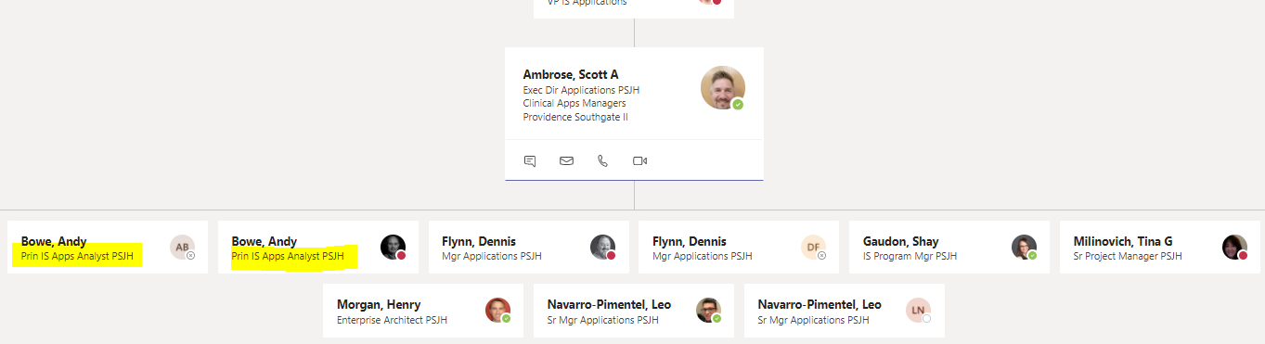
- Reach out to the analyst via Teams and ask for assistance identifying another application owner
If the analyst is unable to assist, notify Wilson Rodriguez. If Wilson cannot identify another application owner, move the application to the Constrained ADO board.
When sending the application to Constrained, tag the F4 team (Ron, Alex, Bill, and Steven) and Wilson in the comments.

